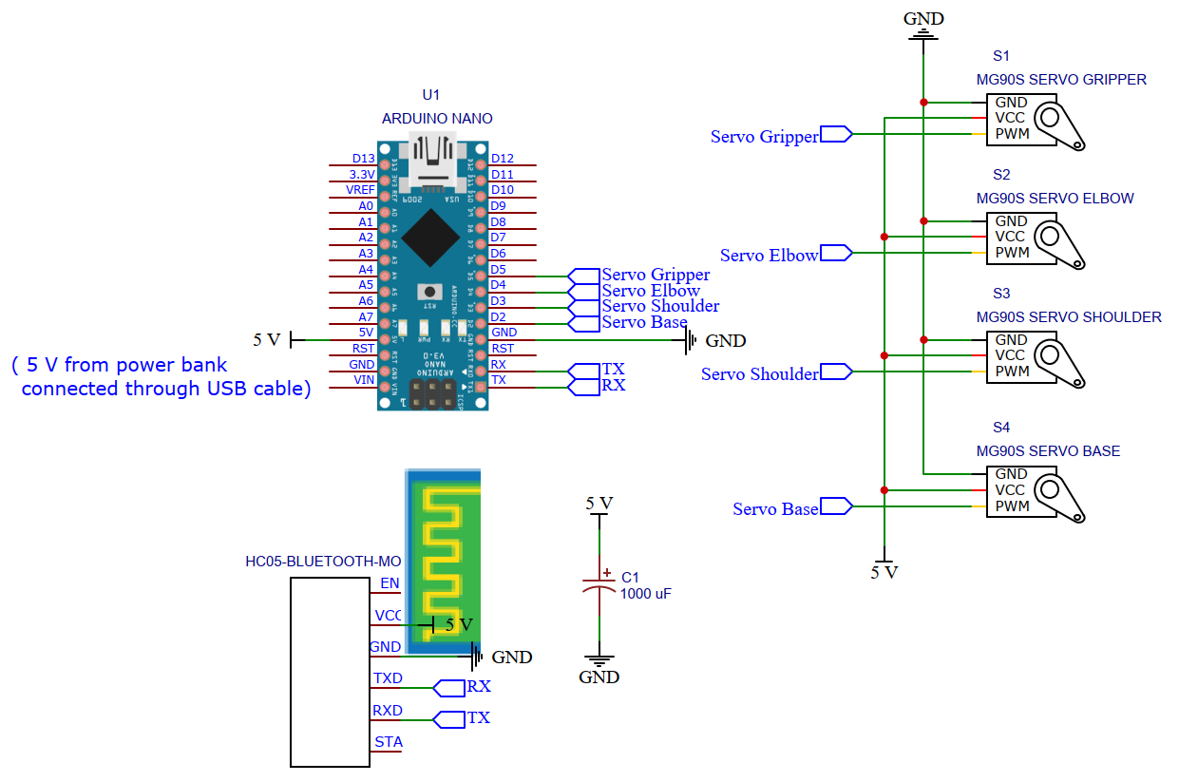

[ SCHEMATIC CIRCUIT DESIGN]

4 SERVO MOTORS ROBOTICS ARM